Monthly report – December 2021

This report outlines The Supplier’s contracted work for continuous development and technical support services with The Client. The scope of the contracted work is split into three parts – developing and maintaining the Monitor project; developing and maintaining the Data Processing pipeline; developing and maintaining the Build & Deployment services for the Client. The goal of the provided services is to ensure smooth operation of the deployed systems, prompt and effective handling of service degradation and performance issues that arise in daily operation, tracking the effectiveness of the deployed services and incremental improvements due to new software developments.

Table of Contents
1. Current development
1.1 Refactor Monitor system
1.2 GUI development updates
1.3 Improvements to task processing queue
2. Incident reports
3. Daily log pull statistics
4. Planned future development
5. Conclusion
Appendix A. Daily log pull statistics
1. Current development

The current development process continues the efforts from the previous month. The focus of this month has been to refactor the monitor system to work with the new logging protocol by the Client – a major disruptive new feature which needed immediate attention. The secondary focuses were to continue work on the GUI project, and to introduce some improvements to the task processing queue.
4.1 Further work on the GUI project. We are going through the customization stage at a rapid pace, and hope to reach the stabilization stage soon
4.2 Refactoring the Monitor system to work with the new logging protocol by the Client – the Client is planning to change their logging protocol to match the needs of their growing data teams. These changes will require significant changes to the way the Monitor system downloads and processes logs, and the tasks in the processing queue will also need to be modified to be able to work through the new logging scheme.
This has been further delayed due to the new logging protocol taking extra time to develop and test.

4.3 Improvements to the task processing queue. After a month of experience with the Celery task system, we’ve identified several weak points in our integration and implementation. After discussion with Client, we have decided to dedicate some time to address these points, as they will lead to improved performance and stability of the system.
1.1 Refactor the Monitor system
The full-scale integration of the Monitor system into the Client’s processes and workflows has created a system that needs to be updated and repurposed whenever the Client’s needs change. As Monitor is no longer a simple module that works as a third-party addon, but is rather a major component of Client’s own development and monitoring processes, any major change on Client’s side could likely cause a refactor needed for Monitor.

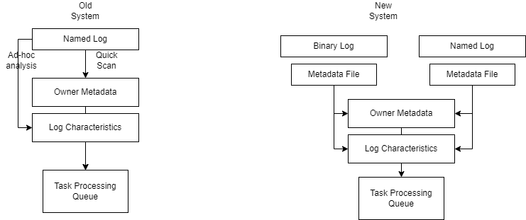
The most pressing such change that is in our sights is the upcoming refactor of the logging mechanism for Client’s main projects and how it pertains to the manipulations by the Monitor system.
The Client’s logging changes are deep and substantial; the way logs are treated is changed completely. Here are the changes that are relevant to the Monitor system:
- Logs are split between plain text and binary logs. Certain logs are either very large, or require very quick logging due to the large bandwidth of data passing through. These logs require different methods of pulling and processing – many of the plain text optimizations applied on log pulling are redundant when working with binary logs, and the identification, fingerprinting and quick analysis applied on plain text logs requires a major refactor in order to be applied on binary logs.
- The logs are encrypted with a new, modular scheme which allows each individual team to hold the keys to their own logs. This is an access control requirement by the Client. This change is particularly difficult to work around, as Monitor needs to be able to identify certain data within a log in order to determine how to process it.
The solution of this has been to develop a log manifest protocol with the help of the Client. The log manifest contains all the metadata that Monitor would normally acquire by reading the logs themselves, and the Client’s projects are responsible for generating it alongside the logs.
The metadata format includes the following fixed elements:
- ownership metadata – previously we would scan a log to determine exactly which team originated the log, which project, version markers and so on. All of this has been standardized as a single ownership metadata package that is now outputted alongside each log file in the metadata log
- task processing characteristics – depending on the log size, log data characteristics and other markers, Monitor would re-order the incoming logs into the task processing queue to best optimize the queue’s processing speed. These markers have been specified in detail by the Monitor team and the Client now implements and prints them into the metadata log
- quick log analysis – for each log, Monitor would collect some basic data that would then be saved in the Monitor database. All of this data is now contained in the metadata log for easy access.
The new process means an even tighter integration between the Client’s projects and the Monitor system – not only does Monitor need to follow Client’s refactors, but any new changes to the metadata require changes to the Client’s software. This bi-directional dependency is new to the Monitor project, as previously we would only receive tasks and requirements from Client, now we’ve opened a full duplex channel of communication with the Client’s development teams in order to facilitate the integration between the two projects.

1.2 GUI development updates
The GUI project is an ongoing development to better surface data available in the Monitor system to the Client’s teams. It was split into three stages:
- initial stage – proof of concept, minimalistic GUI, demonstrate usage, collect feedback
- customization stage – act on feedback, clean up bugs and issues with GUI, collect more feedback, add more sophisticated views and reporting
- stabilization stage – finalize GUIs, lock down data APIs for changes, only minor adjustments
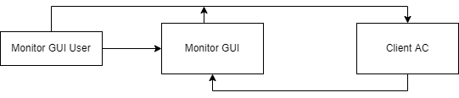
We have made significant progress in our development and understanding of the Client’s needs for the GUI project. As we’ve gone through the customization stage, we’ve learned a lot more about what kind of information each team needs, what they prioritize and how we can better present the inflow of data to them.
The two main improvement channels for this month have been granular access of daily data and access control integration. Access control is critical for the Client, as a lot of the data gathered is sensitive and must be shared only to specific teams. We have integrated the Monitor system with the Client’s own existing access control framework, to allow identification and authorization into Monitor through the existing access control.
Using a chain of connections from client to GUI to Client AC, we can authenticate a user and assign them an authentication token that they can use to access the Monitor GUI. This also allows us to do detailed tracking analysis of the usage patterns of each team, to better understand their needs and identify possible areas of improvement for the project. you to easily create the most common type of datum we use – timestamped series of events.
Granular access to daily data is a new concept introduced into the GUI after extensive communication with the development team. While each team normally has access to raw data immediately as it arrives, the GUI itself relies on the lower priority task queue to generate its aggregates, filters and other data transformations. This means that the GUI’s data always arrives a little late compared to the raw feed. Further, a lot of the data was aggregated as a whole, and we’ve learned that individual members in a team may only need a small slice of data, which can be prioritized and queued early rather than waiting for all the processing. This new knowledge, coupled with the changes made to the task processing queue this month, has allowed us to separate the GUI data aggregation process into three distinct pieces:
- Fast daily data access – this data does not require a lot of processing from the raw data, and can be made available very quickly to the teams that need it. It uses the high priority task queue and is processed alongside the general early processing tasks of the high priority queue
- Granular daily data access – this data needs more processing than the fast access, so it does not qualify to enter the high priority queue. However, it is optimized to be run as soon as pieces of the raw data are processed, identified based on individual team needs. This is services by a series of updated priority task groups which are coordinated to run just after the main processing queue
- Aggregated data statistics – the major data aggregation requires all raw data to be present and pre-processed, and thus can only run after most of the high priority queue has been completed. This is the only data that the GUI had access to initially and it remains unchanged, providing aggregates and other data transformations that are useful to apply over the whole set of data.

1.3 Improvements to task processing queue
The task processing queue is now the core of the Monitor system, by far the most important component of it. To that end, improvements to the task processing queue are both sorely needed, but also must be taken up with the utmost carefulness and precision. This is due to two major issues:
- simulating the task processing queue is difficult, due to the bandwidth and variety of data used. While we can test run individual tasks, testing out major refactors of the queue is difficult, and it is really hard to predict the effects they would have on the daily processing regimen
- interrupting the task processing queue is very painful for all other business processes, which rely on the timely arrival of data to achieve their daily goals. An interruption in the task processing queue does not only disrupt the current day(already a painful and difficult problem to deal with), but due to the sheer volume of processing tasks, backfilling the queue can lead to delays for the next days as well.
Our refactor sought to address both of these issues at the same time, in order to create a more agile and flexible task processing queue that could be updated regularly and suit the Client’s needs, while still maintaining the high throughput and availiability required by the system.
The first set of refactors were mostly of a hardware nature; working with the Client, we set up a full replicate of the task processing queue, which would work with a delay of T-1 days on the already processed data. While this project consumed a lot of effort, especially on the Client’s hardware ops side, it has allowed us to do two very important things with the task processing queue:
- Continuous integration and benchmarking of changes to the task processing queue – since we can record the time it takes for the live processing queue to process data, and we can record a simulated run through the test processing queue, we can then use those two data points and run further individual test runs with minor alterations to tasks or to the core infrastructure of the task processing queue. This allows us to easily catch bugs or regressions, and also confirm whether performance improvements are actually achieved before hitting the live system.

- Re-evaluating the volume and bandwidth requirements for log pulling and task processing, which allows us to give the Client data to make broader scale decisions about how to optimize the day to day business activity. The test processing queue enables a quick demonstration how priority changes and volume changes will impact processing, and these changes can then be deployed instanteously on the live processing queue.
2. Incident reports
This month was fairly uneventful with a limited amount of incidents. Here are the major ones that caused downtime or unexpected shutdowns.
2.1 Task processing queue downtime
Task processing queue downtime is very rare, especially with all the redundant elements in place. However, there are still edge cases and untested side effects that can impact the system. Here is the breakdown of this issue:
2021-12-14 14:00 – The Monitor system detects an anomalous global slowdown of the task processing queue, team starts investigation
2021-12-14 16:00 – The task processing queue is now deadlocked, leading to lost time processing daily business data.
2021-12-14 16:30 – The issue is identified as a deadlock introduced by one of the refactor changes. The refactor is reverted.
2021-12-14 18:00 – Task processing queue is back to normal, but behind 3 hours in processing.
2.2 Live monitor system downtime
The live monitoring system is a light-weight module that monitors the status of all servers and reports it back to a single database. The live monitoring system experienced a brief unexpected and unexplained downtime
2021-12-25 08:30 – Live monitoring system is detected to be non-operational
2021-12-25 10:30 – After investigating for 2 hours, the live monitoring system is restarted and reverts back to normal
2021-12-25 18:00 – The investigation does not manage to uncover the underlying issue
3. Daily log pull statistics
Data log pulling is now a core feature of the Monitor project. The amount of data that is downloaded and processed varies for each day and server. It can be categorized in 4 major categories:
- sta – short term cached calculations throughout the day
- trading – trading logs and executable functional logs
- data – pure market data logs collected to be analyzed later
- mta – longer term calculations, results of live statistical runs and further live data generated by the executables
This data is fed into the Task Queue, with trading data receiving high priority, and the rest ordinary priority. This data then goes through all the processing tasks, to be converted from its raw state to the needed processed state by each team, depending on their designations as well – AD latency, per-server bandwidth availability, average CPU load, average memory usage.
The size of the logs pulled is of direct usefulness to both the Client and the Monitor project, as it is the current primary bottleneck to the processing queue. By summarizing the size of each major category, we can collaborate with the Client’s data team to re-allocate server usage, shuffle data collection and use various other tools at our disposal to streamline the processing queue and achieve maximum efficiency.

In the Appendix we provide a table indexed by day with the log sizes from each server. The sizes can also be summarized and totaled by network connection in order to detect network bandwidth bottlenecks, as well as by processing queue pressure(size * weight of tasks that are run to process the specific log type). We are working with the Client to provide an even fuller picture of the situation with the daily processed logs.
4. Planned future development
At the end of each month, we take a look back and analyze the work done throughout the month, identify pain points and places for improvement. These are then discussed with the Client to reach a plan for future developments, prioritizing the improvements that provide the Client the most value.
For the upcoming month, here are the main planned future developments:

4.1 Further work on the GUI project. The customization stage is reaching a close, and we will advance to the next stage soon.
4.2 Refactoring the Monitor system to work with the new logging protocol by the Client – the Client is planning to change their logging protocol to match the needs of their growing data teams. The refactoring requires more work that will be completed in the following month.
4.3 Improvements to the task processing queue. After a month of experience with the Celery task system, we’ve identified several weak points in our integration and implementation. After discussion with Client, we have decided to dedicate some time to address these points, as they will lead to improved performance and stability of the system. The improvements we started will continue the next month.
5. Conclusion

We are grateful for the opportunity to work with The Client again on optimizing their development and day-to-day work practices. We hope that we can apply our increased expertise and know-how during the interim period to improve on the existing processes and introduce new paradigms to provide The Client with an effective and robust system for managing their development operations.

Appendix A. Daily log statistics
C1. STA



C2. Data

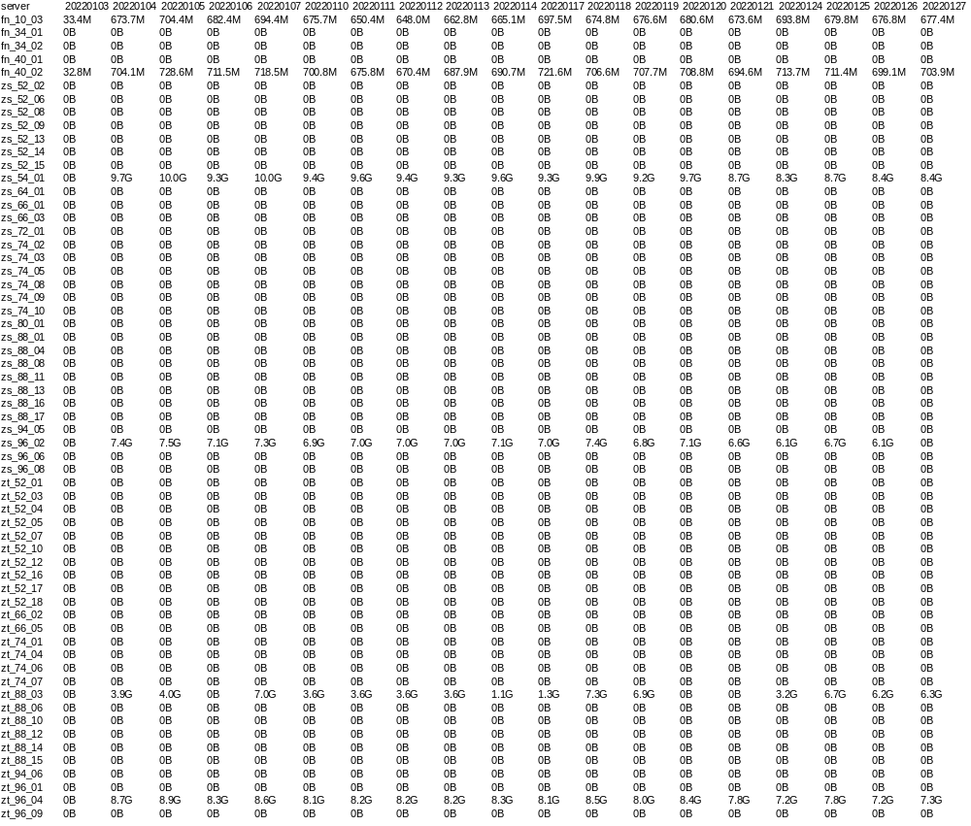

C3. Trading

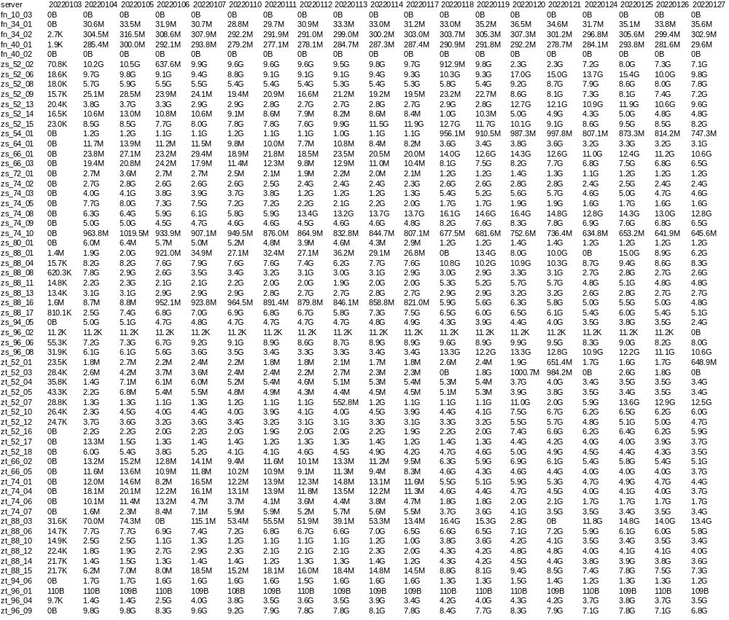

C.4 MTA

